Slowing Down an Amplifying Greenhouse Effect

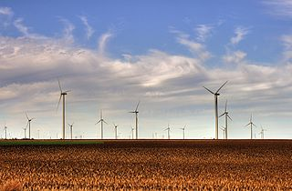
Introduction

Do you live near a wind farm or even a single wind turbine? Have you ever thought about its design and what connection its design purpose has to mitigating climate change? There is rising concern among scientists that the rate of current climate change is extraordinary and likely to have numerous adverse effects on our environment, economy, and quality of life. As you discovered in Lab 3, scientific data strongly implicates increased carbon dioxide emissions from human activities as the primary factor causing the amplified greenhouse effect we see today. Thus, finding ways to reduce the levels of carbon dioxide in the atmosphere becomes a critical strategy in mitigating the adverse effects of climate change happening now and in our future.
Wind Farm In Smoky Hills, TN. Source:
Wikicommons
In Part A, you will begin to understand the design and technology process by examining a middle school student's science fair project designed to absorb carbon dioxide from the air and her father's efforts to scale up her idea to use in artificial trees. Next, you will use an interactive to learn about the pros and cons of carbon reduction technology. In Part B, you will take on the role of a journalist, writing a blog on a promising carbon reduction technology for WIRED, a design and technology magazine. In your research, you will evaluate the pros and cons of the technology and present your findings to your class or others.
By the end of this Lab, you should be able to:
- Evaluate the pros and cons of technologies designed to reduce the amount of carbon dioxide in the atmosphere.

Keeping Track of What You Learn
Throughout these labs, you will find three kinds of questions.
- Checking In questions are intended to keep you engaged and focused on key concepts and to allow you to periodically check if the material is making sense. These questions are often accompanied by hints or answers to let you know if you are on the right track.
- Stop and Think questions are intended to help your teacher assess your understanding of the key concepts and skills you should be learning from the lab activities and readings.
- Discuss questions are intended to get you talking with your neighbor. These questions require you to pull some concepts together or apply your knowledge in a new situation.
Your teacher will let you know which answers you should record and turn in.

Slowing Down an Amplifying Greenhouse Effect

Part A: Using Technology to Reduce CO₂ in the Atmosphere
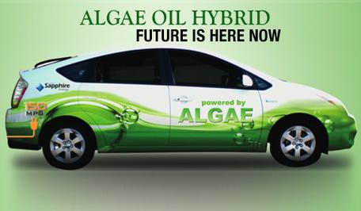
In Chapter 6, you learned that increasing carbon dioxide emissions are creating an amplified greenhouse effect which in turn is leading to a warmer atmosphere. In addition to reducing our use of fossil fuels, innovative design and technology have the potential to play a major role in slowing climate change caused by an amplified greenhouse effect. Some of the key questions that drive the development of innovation and design are:
  - How can we use innovation and technology to decrease CO₂ emissions to the atmosphere?
Driving a car powered by algae - a type of phytoplankton- may be in your future!
- How can we use innovation and technology to reduce the amount of CO₂ already there?
- Will new technologies provide solutions that are viable, sustainable and cost effective?

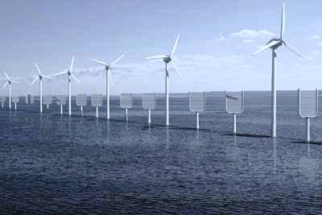
Technology refers to the application of scientific knowledge to some practical purpose and can include applied processes and practices in addition to machines and other technological devices. For example, in Lab 5A, you were introduced to new agricultural practices many ranchers and farmers are using to make carbon-rich soil. This one change in agricultural practice has great potential to reduce the amount of CO₂ in the atmosphere. Thus, carbon reduction technology should include practices such as reforestation and new forms of agriculture in addition to technological approaches like designing and building electric cars and wind turbines and creating new biofuels.

Are winds and artificial tree farms in our future? Courtesy: The Institution of Mechanical Engineers, IPECHE Report.

Carbon reduction technology can include many different types of innovative technological designs and practices

There are two basic strategies in carbon reduction technology:
1. Develop a technology or practice that reduces the amount of carbon dioxide going into the atmosphere.
2. Develop a technology or practice that removes carbon dioxide already in the atmosphere.
Reducing atmospheric CO₂ is indeed a complex problem, one that will most likely need many different technological designs and practices. For example, consider the image above. The wind turbines reduce carbon dioxide emissions by providing an energy source that does not burn fossil fuels. The artificial trees, a new emerging technology, would remove carbon dioxide already in the atmosphere. Wind turbines are familiar and have been around for many years but where did the idea of artificial trees come from? Like any technological design, artificial trees began with good observations and an idea. The hard work begins when trying to turn the idea into a design that works.

Artificial trees are an example of a technology being designed to remove CO₂ from the air
- Watch how a middle school student's idea leads to a technological design for artificial (synthetic) trees in this NovaScienceNow video: Carbon Capture.
- As you watch the video, take notes on the questions below. Your teacher may assign a specific question to your group.
  - What was the initial idea?
  - How does the design work to reduce carbon dioxide in the atmosphere?
  - As the designers moved from the initial idea to a development phase, what worked and what didn't? Did the design change in anyway?
  - Was the design process finished by the end of the video, or was the design still in the development phase?
  - Was there an energy penalty for this design? In other words, was the amount of carbon dioxide reduction greater or less than the amount of energy needed to run the process and/or create the product?
  - What's the cost?

Discuss
In your group or class, discuss the answers to the questions above. Then, identify and discuss any pros or cons that might be associated with the technology of "artificial trees." Is this just an interesting idea, or is it a solution that could actually help to reduce atmospheric CO₂? What do you think?
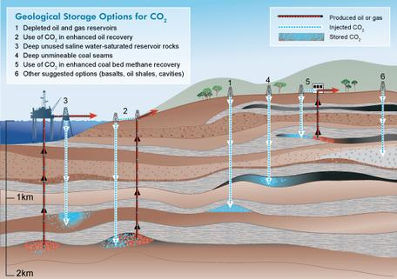

Carbon capture and sequestration is an example of a technology that prevents CO₂ from going into the atmosphere
- Carbon Capture and Sequestration. Source: IPCC.
Consider carbon capture and sequestration (storage) technology depicted in the image on the left. This type of carbon reduction technology captures carbon dioxide at its source and stores it somewhere else. A good example is carbon dioxide that is captured from a power plant and then stored underground in rock. Are there pros and cons with this type of carbon reduction technology?
- To find out, read about various carbon reduction strategies in the NovaScienceNow interactive Where Do We Put the Carbon.
- As you go through the interactive, make note of the pros (potential benefits) and cons (potential drawbacks/unknowns) of each different carbon reduction approach.

Discuss
With a partner or a group, identify two carbon capture technologies from the interactive that have the best potential to be viable solutions for carbon reduction. Explain why you have chosen them.

Discuss
Imagine that you worked for a government, business or organization that was going to invest in a new technology or practice which would reduce CO₂in the atmosphere? What criteria would you apply in your decision-making process?
- With your group and/or class, brainstorm a list of criteria that will help you decide. What potential benefits would you like to see and what potential drawbacks would you like to avoid?

- Use your list to help you in the performance assessment in Lab 8B where you will take on the role of a blogger who has been asked to identify and evaluate a promising carbon reduction technology or practice. Good luck!

Slowing Down an Amplifying Greenhouse Effect

Part B: Evaluating CO₂ Reduction Technology

The following scenario asks you to take on the role of a blogger evaluating some of the new carbon reduction technology.
NASA's Helios experimental solar electric-powered plane. Image source: NASA.

The Scenario:
You have just graduated from college with a degree in journalism and an interest in climate science and technology. After spending several weeks sending out resumes to various newspapers, scientific journals, websites and blogs, you hear from WIRED—a prestigious magazine and on-line periodical that reports on how new and developing technology affects culture, politics and the economy. WIRED is looking for someone with a background in blogging and climate science to start a new on-line blog on innovation and technology that will mitigate climate change.
WIRED has asked you to come in for a first interview and to bring a portfolio of your writing samples to the interview. In addition, WIRED has asked you to write a short piece on a new and promising technology or practice that claims to be able to reduce the amount of CO₂ in the atmosphere thus mitigating the impact of present and future climate change. You will present your blog to an interview team comprised of your classmates and your teacher. At the end of the presentation, your interview team will have the opportunity to ask you questions.
WIRED has e-mailed you instructions for your blog presentation:
- Choose a technology or practice that is designed to mitigate climate change by removing CO₂ from the atmosphere or by reducing the amount of CO_{2.}into the atmosphere. The technology can be in already in use, in the design pipeline or simply envisioned.
Show me some hints on choosing a CO2 reduction technology or practice

Show me some websites to research climate change mitigation technologies and practices
- Then, in a blog on a separate file and no longer than 5 paragraphs and including two visuals, report the following:
  - Describe the mitigation technology or practice. Is it already in use or is it still in the development phase or simply envisioned?
  - Explain how the technology or practice works to reduce carbon dioxide in the atmosphere. Include a visualization of the design or technology.
  - Describe the (pros) potential benefits and (cons) potential drawbacks of the technology or practice. For example, are there risks involved? Does it cost too much? Does it harm the environment in any way?
  - Explain the potential of the technology or practice to mitigate the impact of present and future climate change.
  - Be prepared to share your technology or practice with your class for a class critique. Your class will be choosing the mitigation technologies and/or practices that have the most promise to mitigate climate change.

Discuss
The level of atmospheric CO₂ is close to 400 ppm and continues to rise. Technologies and practices to reduce levels of CO₂in the atmosphere can be costly so organizations and governments must choose wisely. Take on the role of a government or an organization. Which of the technologies or practices described by your peers should your government or organization invest in? Why?
  - Choose two of the best CO₂ reduction technologies and/or practices described by your classmates during their presentations.
  - Compare and contrast them in terms of their potential to reduce current levels of atmospheric CO₂to 350 ppm or perhaps even lower. Why should your government or organization invest in these two carbon reduction strategies compared to the others that were presented?

Adapted from: Carleton College (2016) Earth Labs, Climate and the Carbon Cycle. Published under Creative Commons SA 4.0. Retreived on Aug 31st, 2018 from: https://serc.carleton.edu/eslabs/carbon/lab8.html

